**Student Name: Weight: Contributes to 10% Engagement Mark**

**Student ID:** **Marks:** **Pass/Fail/Award**

# Group Exercise: Single Row Functions

## Equipment and Materials

For this lab, you will need:

* A Windows computer with a minimum of 16GB RAM and 250GB of free disk space, capable of nested virtualization
* Access to ORACLE SQL*PLUS
* The following data provided on Brightspace:
* JustLeeDatabase.zip

## Instructions

1. First, work through steps 2-4 individually. Then arrange a time to come together with your small group. As a group, create one solution based on the best individual solutions for each problem. Further refine the solution as a group as needed.
2. Review the JustLee Bookstore database and physical model.
3. Review the Problem Set, Tips for Success, and Marking Criteria sections of this document.
4. Write a single script that responds to all steps in the problem set.
5. Only one submission is required per group. The submission should include:
   1. One script file
   2. One spool file showing all results
   3. An attribution list that outlines the activities, time spent and resources associated with completing this assignment. A sample attribution list is provided in Brightspace under Course Resources.

## Problem Set

1. JustLee wants to have a sale: 20% off all books, except those that already have a discount associated with them. Produce the sale price list. Carefully note the formatting of the columns in this report. Sort by book title (alphabetically).

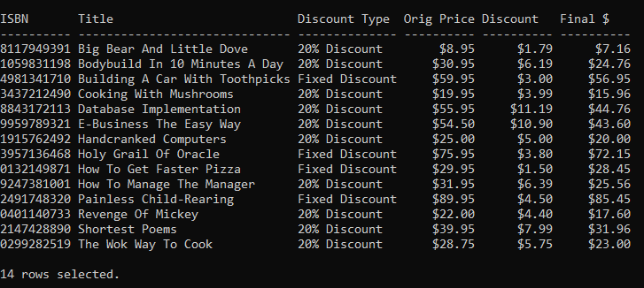

2. Show all customer orders. Carefully note the formatting of the columns.

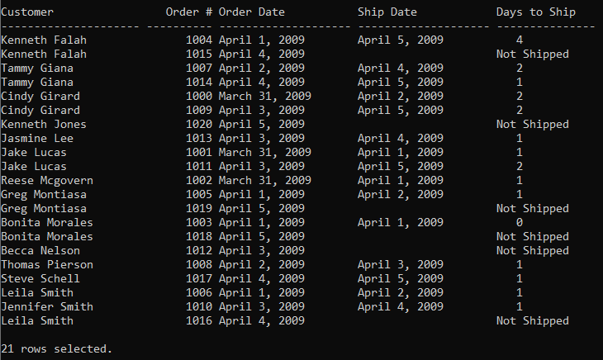

3. Show each customer’s book orders and how old the book was when it was ordered by the number of months. Round the number of months to the closest integer. Carefully note the formatting of the columns. Sort by last name and order#.

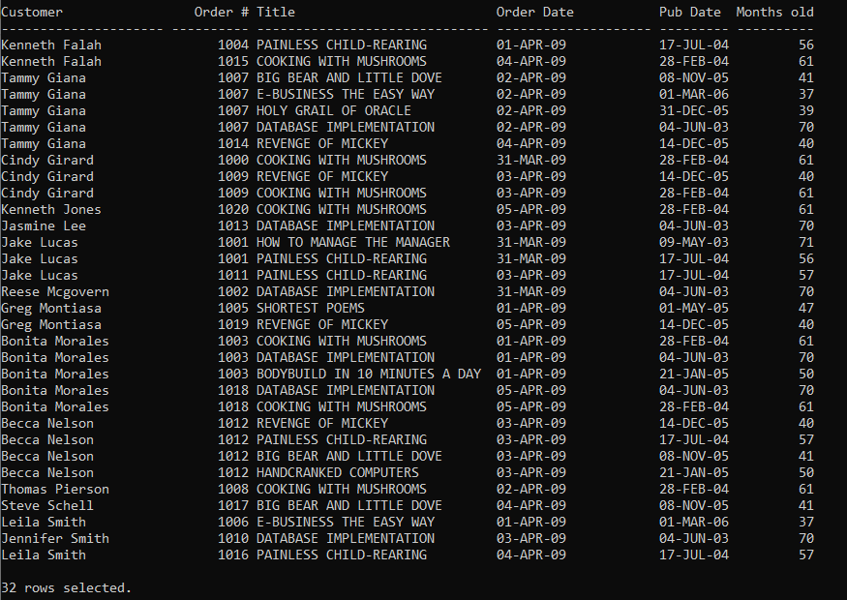

## Tips for Success

1. You can use the following COLUMN commands.
   1. To limit the width of a column, use COLUMN "Final $" FORMAT A20
   2. To clear out the column width settings after the query, use CLEAR COLUMNS
2. You may need to change the page width to avoid having the data wrap around when outputting (i.e. use **set linesize xxx**, where xxx is the width)

## Marking Criteria

You must pass all categories to pass the activity.

|  |  |  |  |
| --- | --- | --- | --- |
| **Categories** | **Fail** | **Pass** | **Score** |
| Submission provided | No | Yes | **Pass/Fail** |
| Attribution list provided | No | Yes | **Pass/Fail** |
| Reasonable attempt to solve each question | No | Yes | **Pass/Fail** |
| Spool file with commands included | No | Yes | **Pass/Fail** |
| **Pass/Fail** | | | |